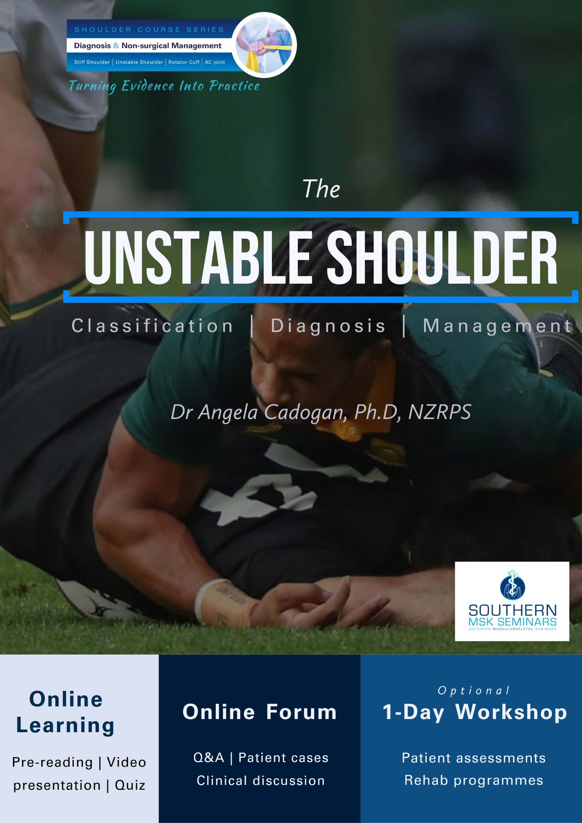

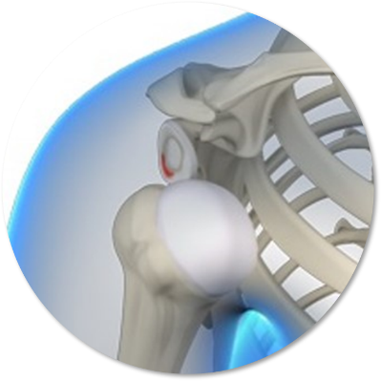
Module 2: The Unstable Shoulder
In this module you will how to classify, diagnose and manage traumatic and atraumatic shoulder instability.

Module Aim
To produce practitioners who:
- understand and can describe the classification and pathoaetiology of traumatic, atraumatic and recurrent shoulder instability.
- can make an accurate diagnosis of shoulder laxity and instability using clinical examination and diagnostic investigations.
- can appropriately refer for, and interpret diagnostic imaging for glenohumeral joint pathologies that may be associated with shoulder instability.
- can appropriately manage glenohumeral instability including appropriate referral for orthopaedic evaluation.
- can apply appropriate and effective physiotherapy treatment and rehabilitation for glenohumeral joint instability (traumatic and atraumatic).

Course Content

There are three lessons in this module:

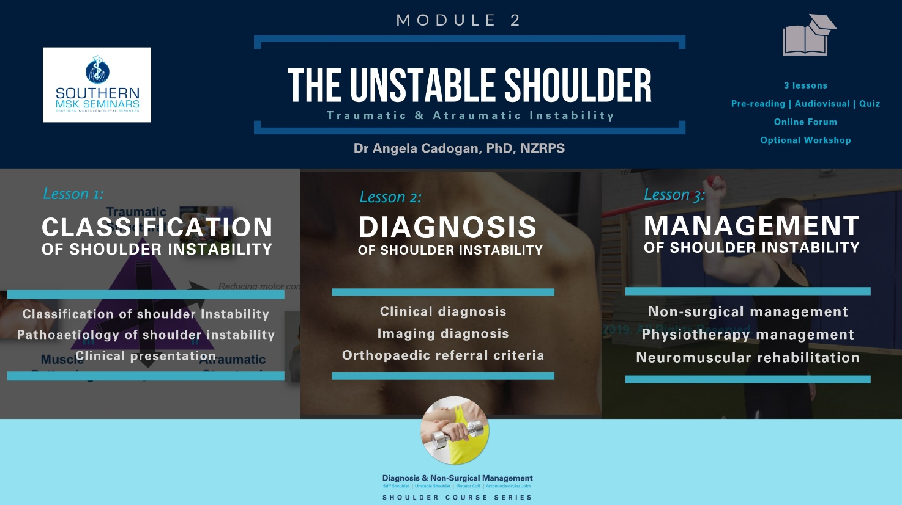

Learning Outcomes
By the end of the module, the participant will be able to:
- Describe the classification of glenohumeral joint instability
- Describe the pathoaetiology of traumatic, atraumatic and recurrent GHJ instability including muscle patterning instability.
- Describe the clinical features, including patient history and physical examination features of traumtic and atraumatic GHJ instability.
- Perform a detailed patient history and physical examination to identify GHJ hyperlaxity and instability.
- Understand and list the criteria for referral for diagnostic imaging investigations for the unstable shoulder.
- Read and interpret the findings from plain-film x-rays and diagnostic ultrasound scans of the shoulder and understand the clinical relevance of findings from other imaging investigations e.g MRI.
- Describe the evidence-based management of GHJ instability.
- List the criteria and priority for referral for orthopaedic assessment for GHJ instability.
- Describe evidence-based physiotherapy management for shoulder instability.

Learning Activities
Each lesson in this module consists of a range of learning activities including:
- Pre-reading articles
- Audiovisual presentation
- Additional clinical resources
- Quiz
A manual is provided for each lesson that includes copies of slide presentations, references and additional learning resources.

Study Time
Study time for this module is approx. 16 hours. (Approx 3-4 hours per lesson)

Workshop
An optional, 1-day workshop will be held for this module. This is available to any student who completes all lessons in this module. The workshop is entirely practical and will include:
- Physical examination test demonstration and practice
- Differential diagnosis and clinical reasoning exercises
- Real-time patient assessment
- Physiotherapy treatment and rehabilitation case studies

Social Learning

The following are available to anyone who completes all lessons in the Unstable Shoulder module:

Online Forum
One online forum per year will be held for this module. The forum is run by the module teacher (Dr Angela Cadogan) through Skype or Zoom. The purpose is to provide an informal learning forum where students can ask questions from any of the lessons in this module, share patient cases and other clinical questions. You can continue to join these forums each year, even after you have completed the online module.
A link to the forum will be sent to all those enrolled the full module closer to the time. See the SMS website for online forum dates.

Facebook Group
Those who complete all modules in this course will be invited to join the “Unstable Shoulder” Facebook Group upon completion of the course. Membership to this Group is indefinite. The purpose of the Group is to keep you up to date with latest research and clinical developments in this area and to interact with other students regarding patient cases.
This Group contains social learning units where latest research and updates are organised by topics that align with the modules in this course. You can check off the items you complete and use this for CPD purposes.
In this Group you can:
- post questions about the online learning material
- share relevant clinical information/cases and research updates with other students
- receive notifications of any upcoming events relevant to the topic (e.g online chats, seminars etc)
- Keep track of your CPD by completing the learning units for each topic.

Continuing Education Certificates
After completion of the Module, you will receive a Certificate of Completion. If you score more than 75% in the quizzes, you will receive a Certificate of Achievement. CPD certificates are sent after the course evaluation has been completed online (found in the “Module Completion” section).

Copyright Notice
The materials provided in this course are protected by copyright and are to be used solely for educational purposes by students enrolled in Southern Musculoskeletal Seminars courses and its teachers. You may not sell, alter or further reproduce, share or distribute any part of this material to any other person. Where provided to you in electronic format, you may only print from it for your own private study and research.
User access to Southern Musculoskeletal Seminars eLearning accounts and lesson content is strictly for the individual named on the enrolment only. Access to user accounts is monitored. Any unauthorized access, password sharing, video link or document sharing, distribution or presentation of SMS learning content to any other individuals, organisations or other parties is strictly prohibited and may result in your enrolment being terminated without refund of fees already paid for any SMS course. Enrolment in any current or future SMS courses will also be forfeited.
Failure to comply with the terms of this warning may expose you to legal action for copyright infringement.

Before you begin
It is recommended you follow SMS on Twitter or Facebook, or check the SMS website to receive notifications of new lessons, updates and clinical resources related to the Shoulder Course Series.

For More Information
If you want more information about the Shoulder Course Series please visit www.musculoskeletal.courses/

