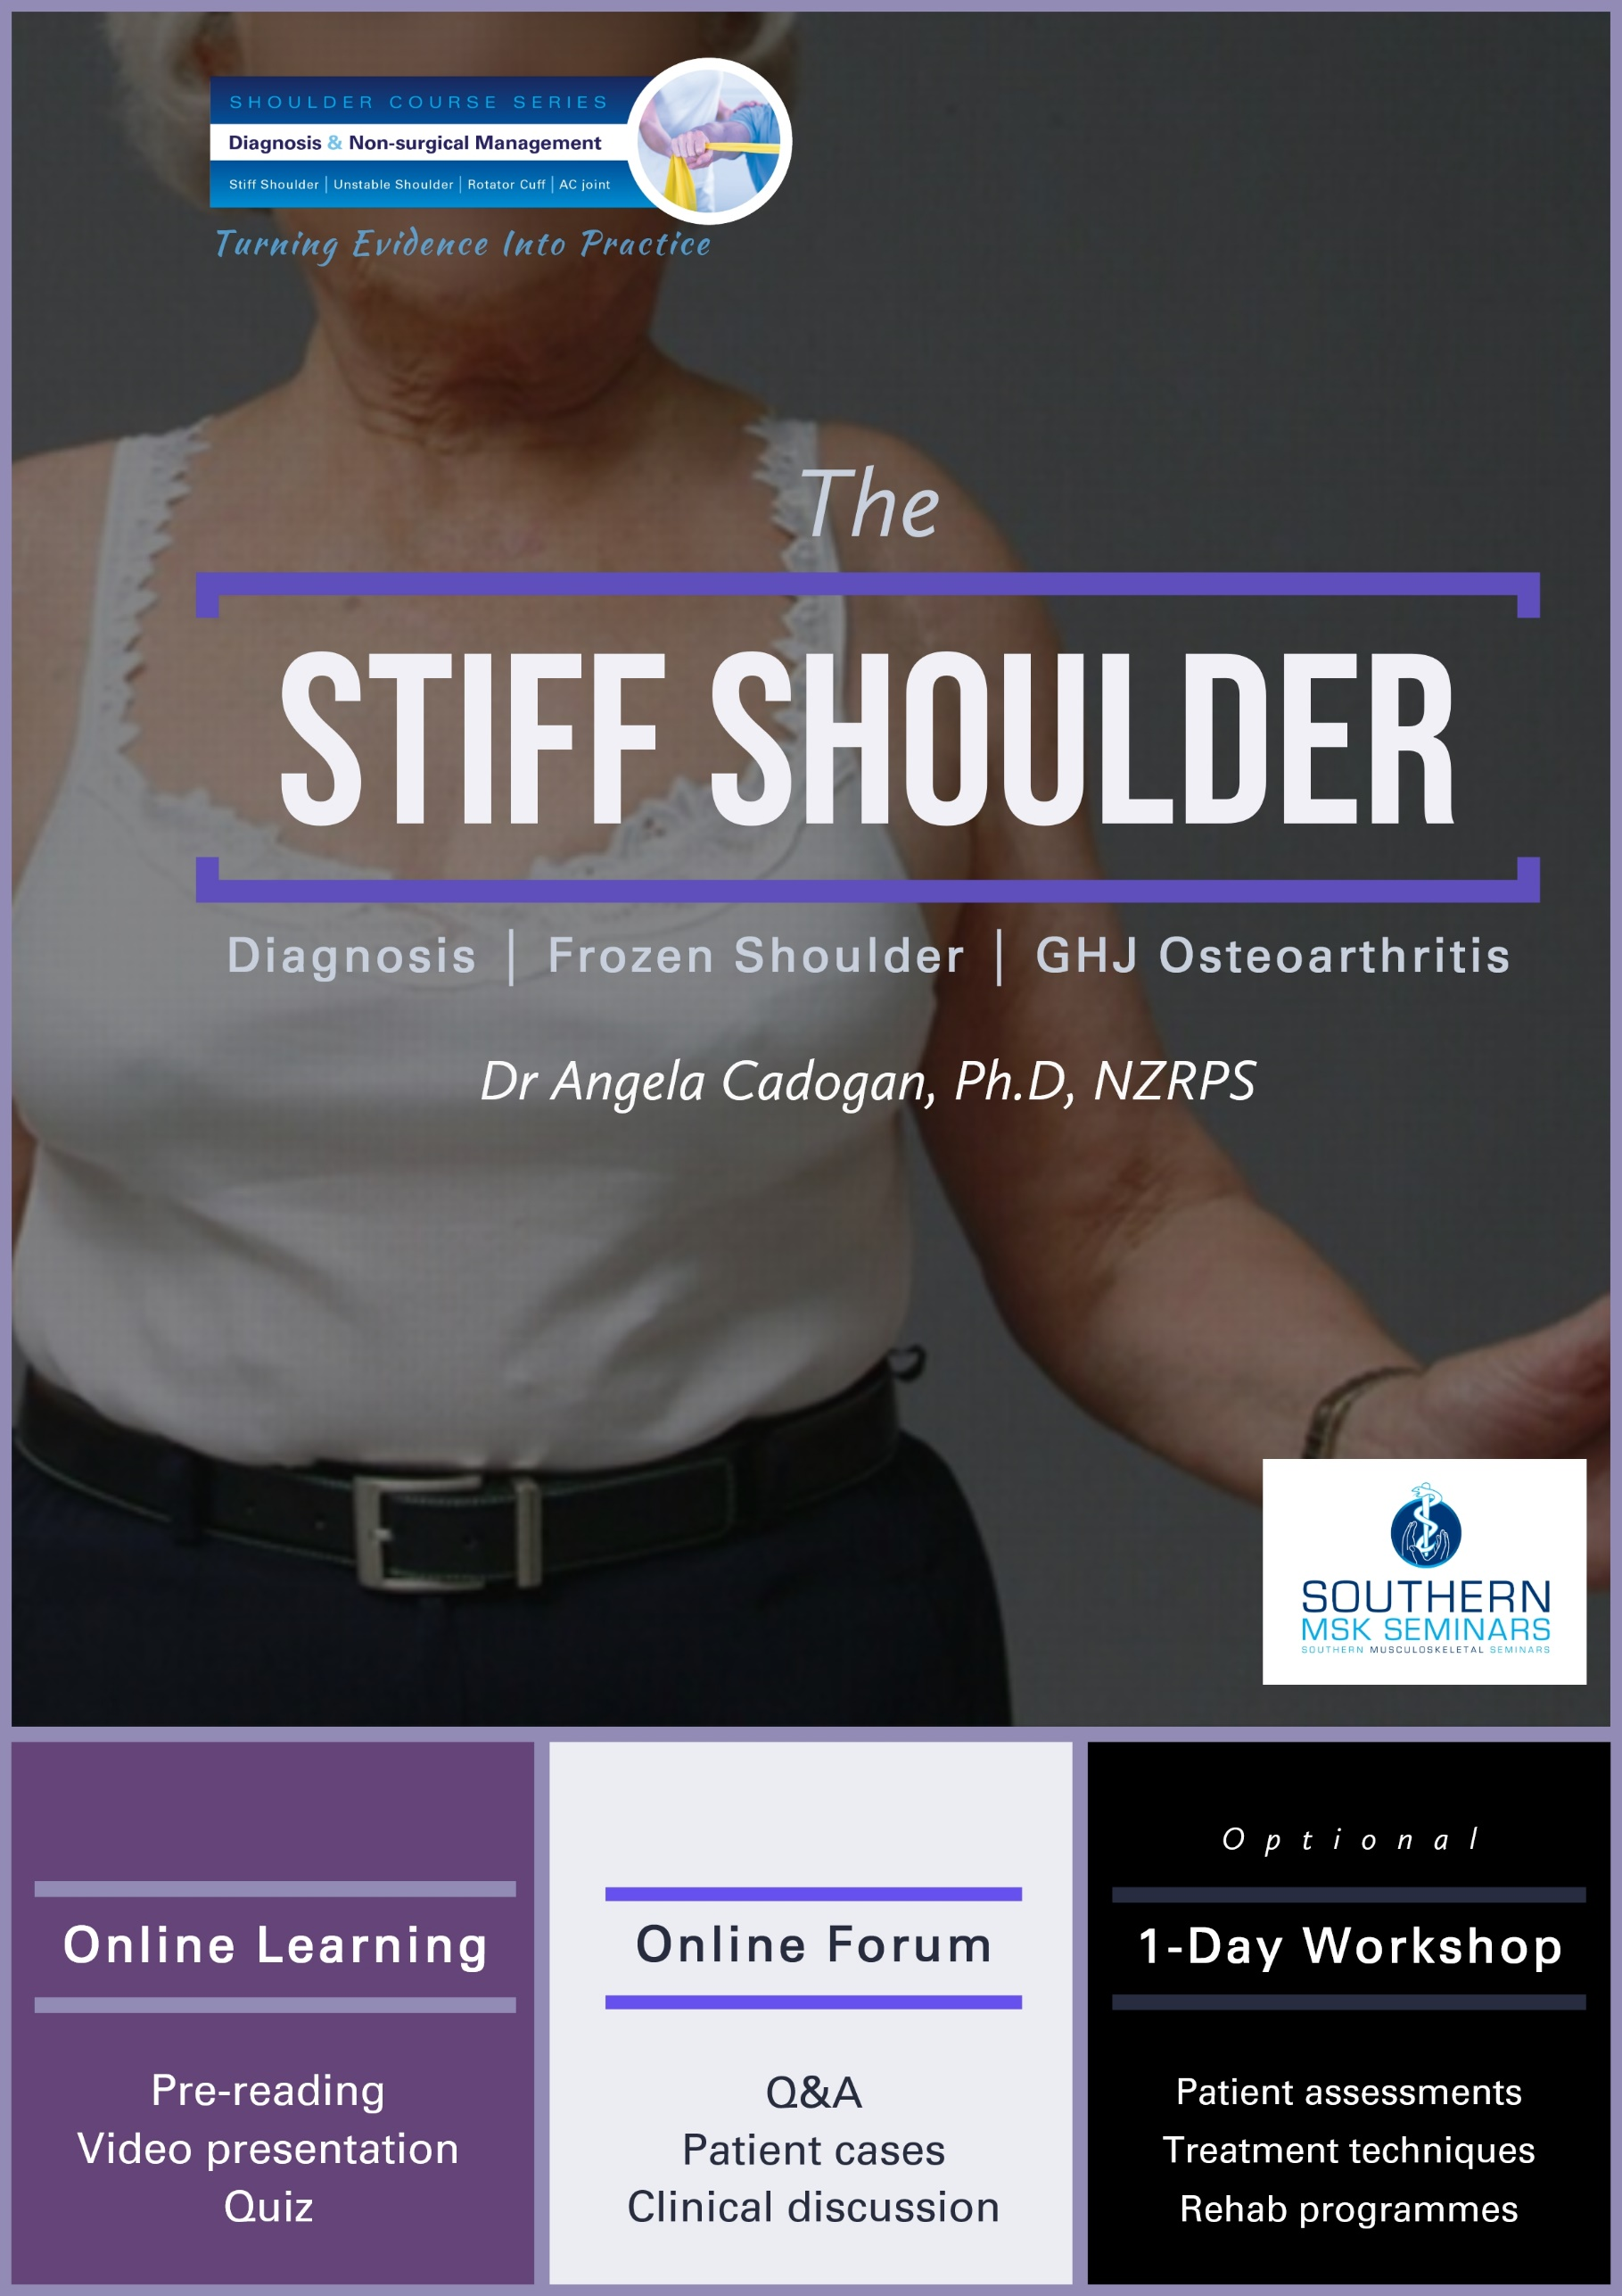

Module 1: The Stiff Shoulder
In this module you will learn how to make an accurate diagnosis of stiff shoulder conditions using clinical examination and diagnostic imaging, and how to apply evidence-based, non-surgical management for frozen shoulder and glenohumeral osteoarthritis.

Module Aim
To produce practitioners who can:
- Make an differential diagnosis of ‘stiff shoulder’ shoulder conditions
- Appropriately refer for, and interpret diagnostic imaging
- Apply appropriate non-surgical management for stiff shoulder conditions, including appropriate physiotherapy management and rehabilitation.
- Appropriately refer patients with stiff shoulder conditions for orthopaedic evaluation.

Course Content

There are three lessons in this module.

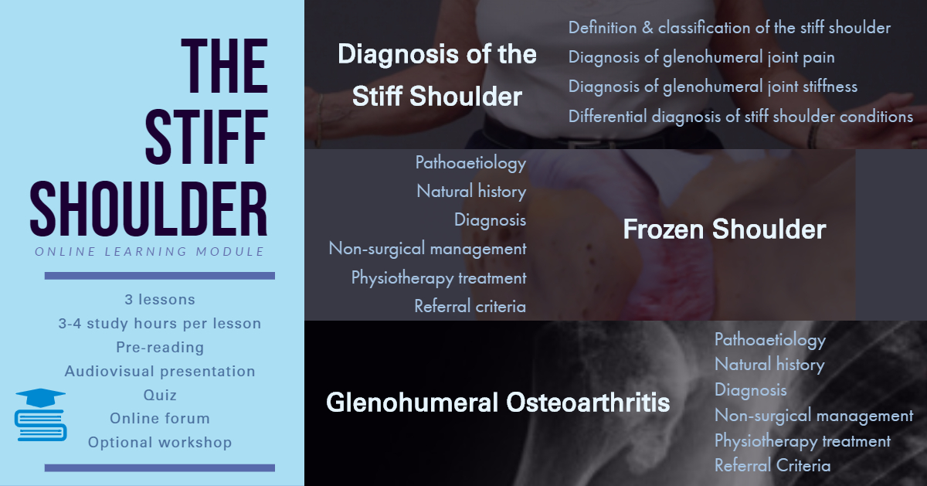

Learning Outcomes
By the end of the module, the participant will be able to:
- Describe the pathoaetiology and natural history of frozen shoulder and glenohumeral joint (GHJ) osteoarthritis (OA).
- Describe the clinical features, including patient history and physical examination features of frozen shoulder and GHJ OA including how these relate to pathology.
- Perform a detailed patient history and physical examination of a patient with a ‘Stiff Shoulder’.
- Understand and list the criteria for referral for diagnostic imaging investigations for the Stiff Shoulder.
- Appropriately interpret the findings from plain-film x-rays and diagnostic ultrasound scans of the shoulder.
- Describe the evidence-based management of frozen shoulder and GHJ OA.
- Describe and apply appropriate, evidence-informed physiotherapy treatment and rehabilitation for frozen shoulder and GHJ OA.
- List the criteria and priority for referral for orthopaedic assessment for the Stiff Shoulder.

Learning Activities
Each lesson in this module consists of a range of learning activities including:
- Pre-reading articles
- Audiovisual presentation
- Additional clinical resources
- Quiz
A manual is provided for each lesson that includes copies of slide presentations, references and additional learning resources.

Study Time
Study time for the online “Stiff Shoulder” module is approx. 16 hours. (Approx 3-4 hours per lesson)

Stiff Shoulder Workshop
An optional, 1-day workshop will be held for this module. This is available to any student who completes all lessons in the Stiff Shoulder module. The workshop is entirely practical and will include:
- Physical examination test demonstration and practice
- Differential diagnosis and clinical reasoning exercises
- Real-time patient assessment
- Physiotherapy treatment and rehabilitation case studies

Social Learning

The following are available to anyone who completes all lessons in the Stiff Shoulder module:

Online Forum
One Stiff Shoulder online forum is run by the module teacher (Dr Angela Cadogan) and will be held once per year via Skype or Zoom. The purpose is to provide an informal learning forum where students can ask questions from any of the lessons in this module, share patient cases and other clinical questions. You can continue to join these forums each year, even after you have completed the online module.
A link to the forum will be sent to all those enrolled the full module closer to the time. See the SMS website for online forum dates.

Facebook Group
Those who complete all modules in this course will be invited to join the “Stiff Shoulder” Facebook Group upon completion of the course. Membership to this Group is indefinite. The purpose of the Group is to keep you up to date with latest research and clinical developments in this area and to interact with other students regarding patient cases.
This Group contains social learning units where latest research and updates are organised by topics that align with the modules in this course. You can check off the items you complete and use this for CPD purposes.
In this Group you can:
- post questions about the online learning material
- share relevant clinical information/cases and research updates with other students
- receive notifications of any upcoming events relevant to the topic (e.g online chats, seminars etc)
- Keep track of your CPD by completing the learning units for each topic.

Continuing Education Certificates
After completion of the Module, you will receive a Certificate of Completion. If you score more than 75% in the quizzes, you will receive a Certificate of Achievement. CPD certificates are sent after the course evaluation has been completed online (found in the “Module Completion” section).

Copyright Notice
The materials provided in this course are protected by copyright and are to be used solely for educational purposes by students enrolled in Southern Musculoskeletal Seminars courses and its teachers. You may not sell, alter or further reproduce, share or distribute any part of this material to any other person. Where provided to you in electronic format, you may only print from it for your own private study and research.
User access to Southern Musculoskeletal Seminars eLearning accounts and lesson content is strictly for the individual named on the enrolment only. Access to user accounts is monitored. Any unauthorized access, password sharing, video link or document sharing, distribution or presentation of SMS learning content to any other individuals, organisations or other parties is strictly prohibited and may result in your enrolment being terminated without refund of fees already paid for any SMS course. Enrolment in any current or future SMS courses will also be forfeited.
Failure to comply with the terms of this warning may expose you to legal action for copyright infringement.

Before you begin
It is recommended you follow SMS on Twitter or Facebook, or check the SMS website to receive notifications of new lessons, updates and clinical resources related to the Shoulder Course Series.

For More Information
If you want more information about the Shoulder Course Series please visit www.musculoskeletal.courses/

