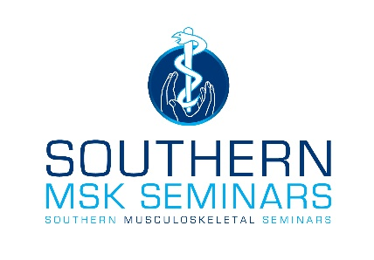
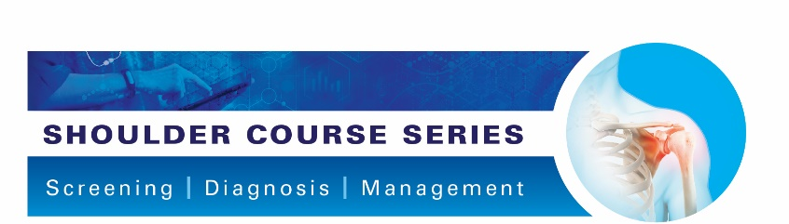
Turning Evidence Into Practice

Shoulder Screening

Dr Angela Cadogan, PhD, NZRPS
Physiotherapy Specialist (Musculoskeletal)
M.Sports Physio, Dip MT, PG Cert Health Studies (Sport & Exercise)

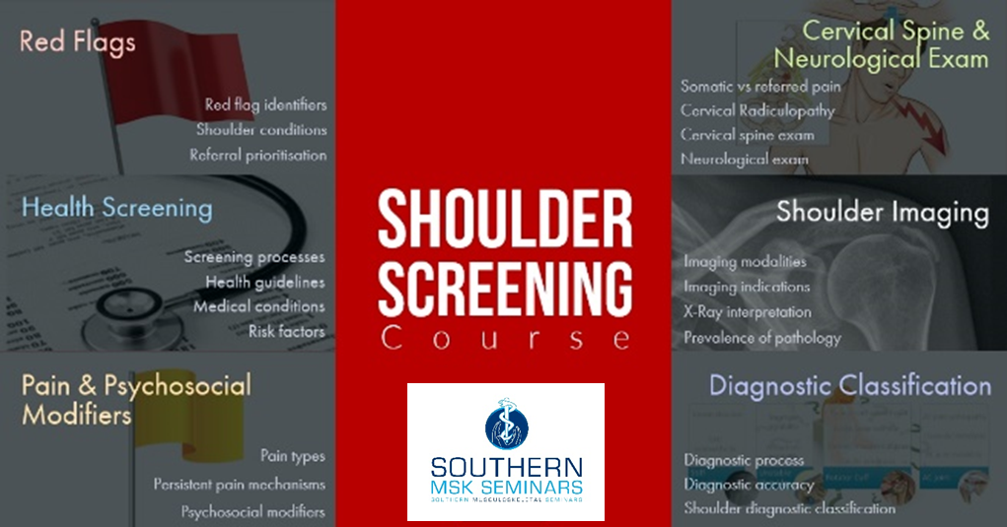

Shoulder Screening Course
In this course you will learn how to systematically work through a process of screening the patient for red flags, excluding other causes of shoulder pain, obtaining appropriate diagnostic imaging, and then classifying shoulder pain into categories that guide management.

Course Aim
To produce practitioners who can:
- Accurately screen patients presenting with shoulder girdle symptoms for red flags, and other causes of symptoms that may require additional investigation or treatment in the primary contact setting.
- Read basic shoulder x-ray views and interpret findings in the context of patient symptoms
- Classify patients with shoulder symptoms into diagnostic categories that help guide management.

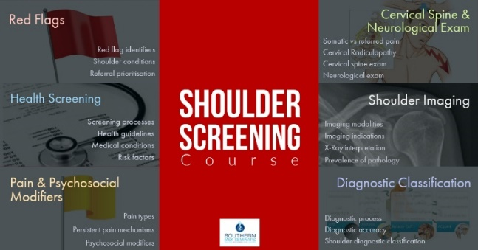
Course Content

There are six modules in this course:

Red Flags
You will learn to screen for red flag indicators of potentially serious pathology and refer the patient for necessary evaluation within an appropriate time-frame.

Health Screening
You will learn current health guidelines for alcohol, tobacco and physical activity, and how to screen for risk factors and atypical symptoms and signs of medical conditions that may present with shoulder symptoms.

Pain and Psychosocial Modifiers
In this module you will learn the pathoaetiology and features of various pain states, including the mechanisms behind persistent pain. You will learn how to screen for and manage psychosocial factors and learn about their relationship to persistent pain.

Cervical Spine and Neurological Examination.
In this module you will learn about the difference between somatic and radicular pain and how to examine the cervical spine to identify local, or referred pain. You will learn the diagnostic features of cervical radiculopathy, how to perform an accurate and thorough neurological examination.

Shoulder Imaging
In this module you will learn about the strengths and limitations of imaging modalities, indications for imaging, prevalence of imaged pathology and how to read and interpret basic shoulder x-ray views.

Diagnostic Classification of Shoulder Conditions
This module defines “diagnosis”, highlights the importance of the diagnostic process, provides a brief overview of diagnostic accuracy and presents a clinical classification system for shoulder conditions that forms the basis of the modules in the “Diagnosis and Non-Surgical Management” Course.

Learning Outcomes
By the end of the course, the participant will be able to:
- Identify red flag indicators of serious pathology and refer appropriately.
- Undertake an efficient and effective health screen for lifestyle and health risk factors, and symptoms and signs of systemic medical conditions presenting with shoulder pain and refer appropriately.
- Describe the features of different pain states, the mechanisms underpinning persistent pain, and explain the relationship of psychosocial factors to persistent pain.
- Competently perform an examination of the cervical spine and neurological examination of the upper limb to identify pain referred from the cervical spine or evidence of neurological compromise.
- Appropriately refer for diagnostic imaging, and describe the strengths and limitations of basic shoulder x-ray views for identifying specific shoulder pathology.
- Describe the diagnostic classification of the main categories of shoulder conditions that can be identified clinically to guide management.

Learning Content
Each module consists of a range of learning activities including:
- Pre-reading articles
- Audiovisual presentation
- Quiz
- Online forum*
- Ongoing access to closed Facebook group*
*Available to those enrolled in the full Screening Course
A manual is provided for each module that includes copies of slide presentations, references and additional learning resources.

Study Time
Study time for the Shoulder Screening Course is approx. 20 hours. (Approx 3-4 hours per module)

Social Learning

Online Forum
Those enrolled in all modules in this course will be invited to attend the online forum led by Dr Angela Cadogan, The purpose of this informal online forum is to ask any questions you have from the online learning material and to discuss any patient cases. A link to the forum will be sent to all those enrolled the full course closer to the time. See the SMS website for online forum dates.

Facebook Group
Those who complete all modules in this course will be invited to join the “Stiff Shoulder” Facebook Group upon completion of the course. Membership to this Group is indefinite. This Group contains social learning units where latest research and updates are organised by topics that align with the modules in this course. You can check off the items you complete and use this for CPD purposes.

Continuing Education Certificates
After completion of the Course, you will receive a Certificate of Completion. If you score more than 75% in the quizzes, you will receive a Certificate of Achievement.

Copyright Notice
The materials provided in this course are protected by copyright and are to be used solely for educational purposes by students enrolled in Southern Musculoskeletal Seminars courses and its teachers. You may not sell, alter or further reproduce or distribute any part of this material to any other person. Where provided to you in electronic format, you may only print from it for your own private study and research. Failure to comply with the terms of this warning may expose you to legal action for copyright infringement.

Before you begin
It is recommended you follow SMS on Twitter or Facebook, or check the SMS website to receive notifications of new lessons, updates and clinical resources related to the Shoulder Course Series.

For More Information
If you want more information about the Shoulder Course Series please visit www.musculoskeletal.courses/

