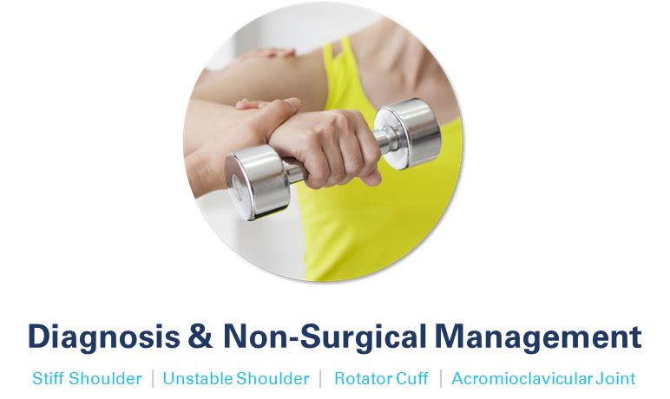

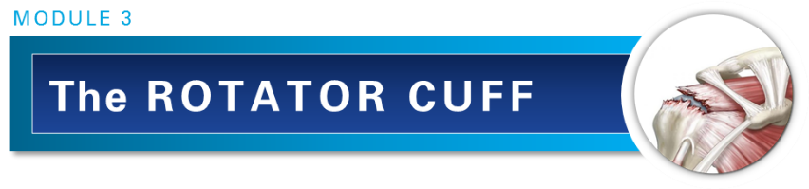
Dr Angela Cadogan, PhD, NZRPS
Physiotherapy Specialist (Musculoskeletal)
PhD, M.Sports Physio, Dip MT, PG Cert Health Studies (Sport & Exercise)

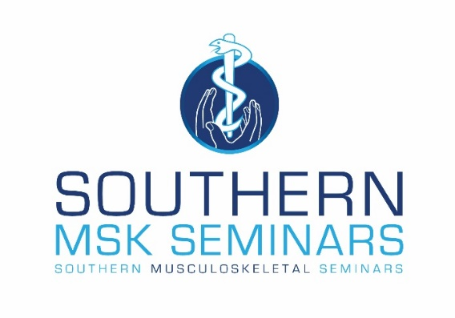

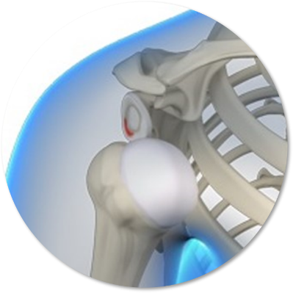
Module 3: The Rotator Cuff
This module covers the pathoaetiology, natural history, diagnosis and management of rotator cuff-related conditions. Lessons in this module begin with the diagnosis of subacromial pain and are then divided according to evidence for specific management of rotator cuff related conditions.

Module Aim
To produce practitioners who:
- Understand the spectrum of subacromial pathology including aetiology and natural history.
- Can make an accurate clinical diagnosis of symptomatic subacromial conditions and make appropriate use of imaging in the diagnostic process.
- Are competent in the non-operative management of subacromial pathology.
- Can apply appropriate and effective physiotherapy treatment and rehabilitation for subacromial conditions.
- Can appropriately refer for surgical evaluation of rotator cuff conditions.

Module Content

There are five lessons in this module:

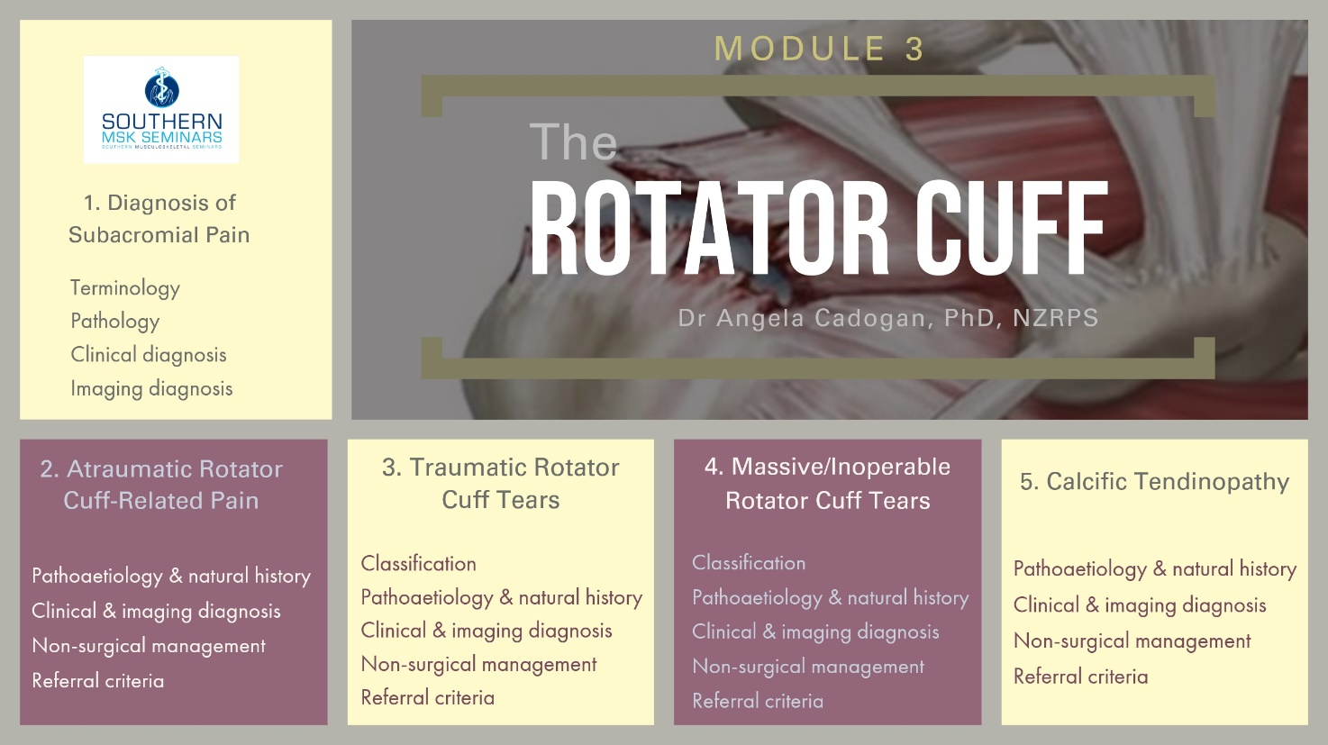

Learning Outcomes
- Describe the pathoaetiology and natural history of calcific, and non-calcific rotator cuff tendon and bursal pathology.
- Describe the clinical features, including patient history and physical examination features of calcific and non-calcific rotator cuff tendon and bursal pathology and how these relate to pathology.
- Perform a detailed patient history and physical examination to identify and sub-classify rotator cuff conditions according to evidence for specific management.
- Understand and list the criteria for referral for diagnostic imaging investigations for subacromial pathology and interpret results in the context of patients symptoms.
- Describe the evidence-based management of calcific and non-calcific rotator cuff tendon and bursal pathology.
- List the indications and contraindications for the use of diagnostic and corticosteroid injections into the subacromial space.
- Describe and perform appropriate, evidence-informed physiotherapy management for subacromial pathologies.
- List the criteria and priority for referral for orthopaedic assessment for subacromial pathologies.

Learning Activities
Each lesson in this module consists of a range of learning activities including:
- Pre-reading articles
- Audiovisual presentation
- Additional clinical resources
- Quiz
A manual is provided for each lesson that includes copies of slide presentations, references and additional learning resources.

Study Time
Study time for this module is approx. 20 hours. (Approx 3-4 hours per lesson)

Workshop
An optional, 1-day workshop will be held for this module. This is available to any student who completes all lessons in this module. The workshop is entirely practical and will include:
- Physical examination test demonstration and practice
- Differential diagnosis and clinical reasoning exercises
- Real-time patient assessment
- Physiotherapy treatment and rehabilitation case studies

Social Learning

The following are available to anyone who completes all lessons in the Rotator Cuff module:

Online Forum
One online forum per year will be held for this module. The forum is run by the module teacher (Dr Angela Cadogan) through Skype or Zoom. The purpose is to provide an informal learning forum where students can ask questions from any of the lessons in this module, share patient cases and other clinical questions. You can continue to join these forums each year, even after you have completed the online module.
A link to the forum will be sent to all those enrolled the full module closer to the time. See the SMS website for online forum dates.

Facebook Group
Those who complete all modules in this course will be invited to join the “Rotator Cuff” Facebook Group upon completion of the course. Membership to this Group is indefinite. The purpose of the Group is to keep you up to date with latest research and clinical developments in this area and to interact with other students regarding patient cases.
This Group contains social learning units where latest research and updates are organised by topics that align with the modules in this course. You can check off the items you complete and use this for CPD purposes.
In this Group you can:
- post questions about the online learning material
- share relevant clinical information/cases and research updates with other students
- receive notifications of any upcoming events relevant to the topic (e.g online chats, seminars etc)
- Keep track of your CPD by completing the learning units for each topic.

Continuing Education Certificates
After completion of the Module, you will receive a Certificate of Completion. If you score more than 75% in the quizzes, you will receive a Certificate of Achievement. CPD certificates are sent after the course evaluation has been completed online (found in the “Module Completion” section).

Copyright Notice
The materials provided in this course are protected by copyright and are to be used solely for educational purposes by students enrolled in Southern Musculoskeletal Seminars courses and its teachers. You may not sell, alter or further reproduce, share or distribute any part of this material to any other person. Where provided to you in electronic format, you may only print from it for your own private study and research.
User access to Southern Musculoskeletal Seminars eLearning accounts and lesson content is strictly for the individual named on the enrolment only. Access to user accounts is monitored. Any unauthorized access, password sharing, video link or document sharing, distribution or presentation of SMS learning content to any other individuals, organisations or other parties is strictly prohibited and may result in your enrolment being terminated without refund of fees already paid for any SMS course. Enrolment in any current or future SMS courses will also be forfeited.
Failure to comply with the terms of this warning may expose you to legal action for copyright infringement.

Before you begin
It is recommended you follow SMS on Twitter or Facebook, or check the SMS website to receive notifications of new lessons, updates and clinical resources related to the Shoulder Course Series.

For More Information
If you want more information about the Shoulder Course Series please visit www.musculoskeletal.courses/

